Stopwatch
# Source: AI Source: Provided by: [Data Path: Persons Table -> ID Column: 1, Name_En Column: Motasem Essam] -> From: [ChatGPT] on [7/17/2026]
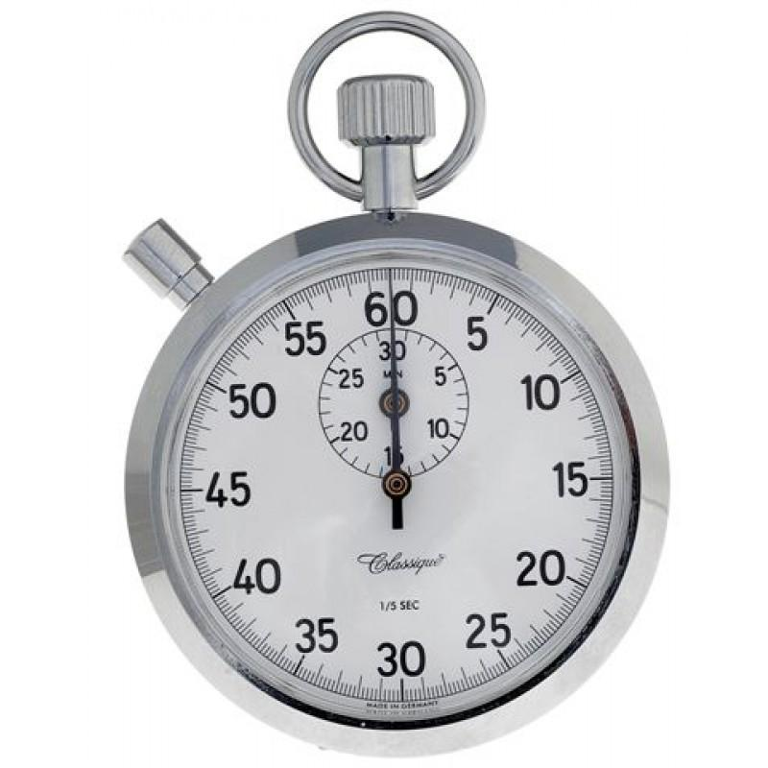
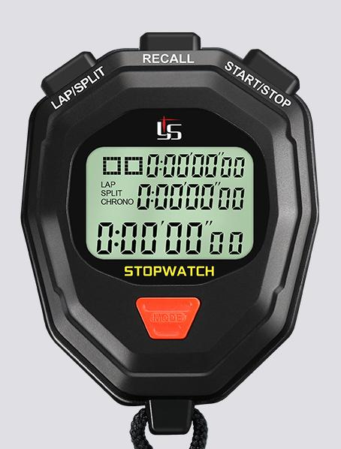
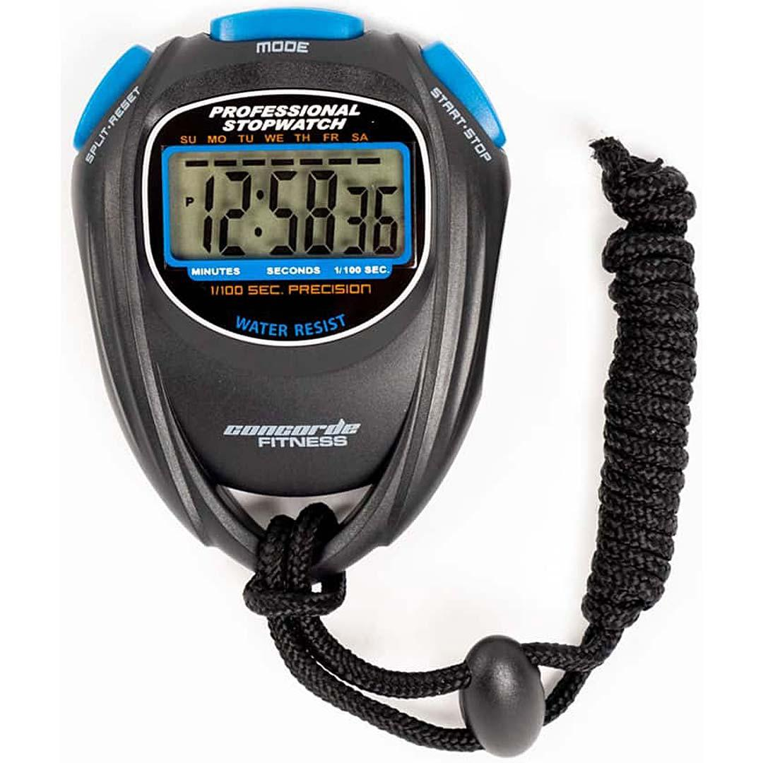
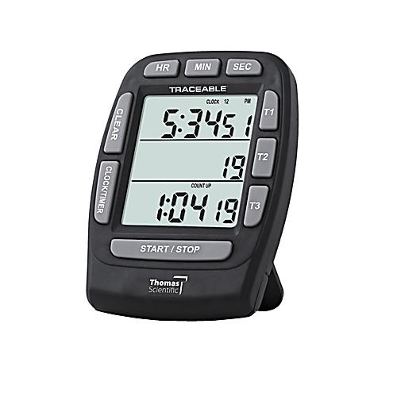
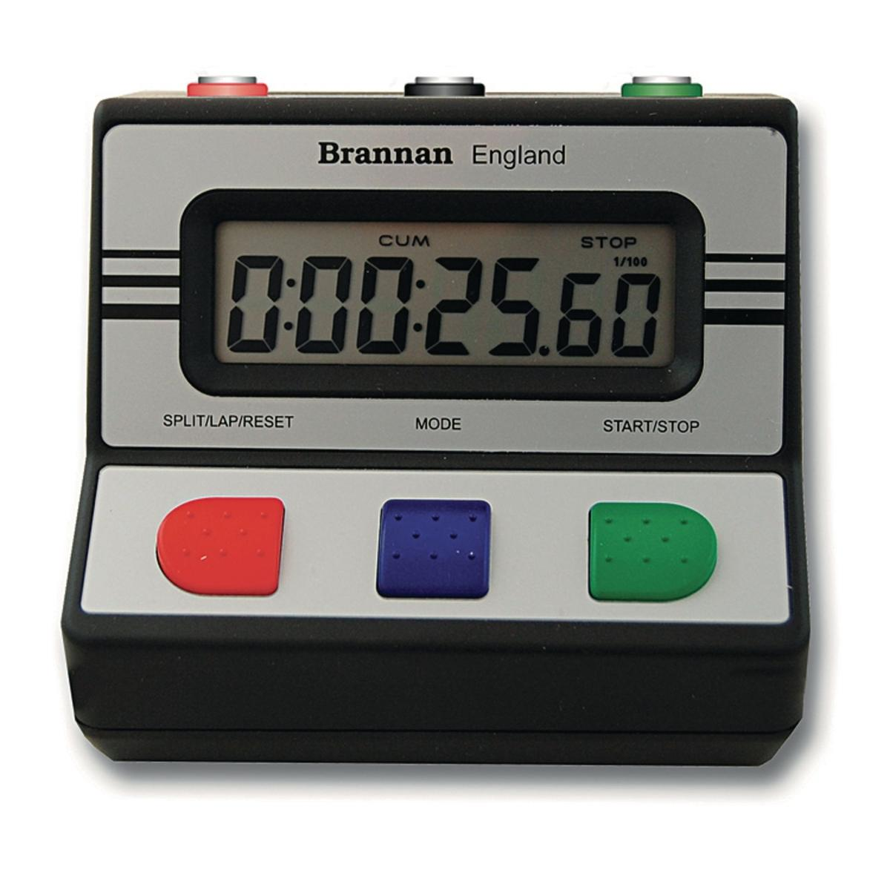
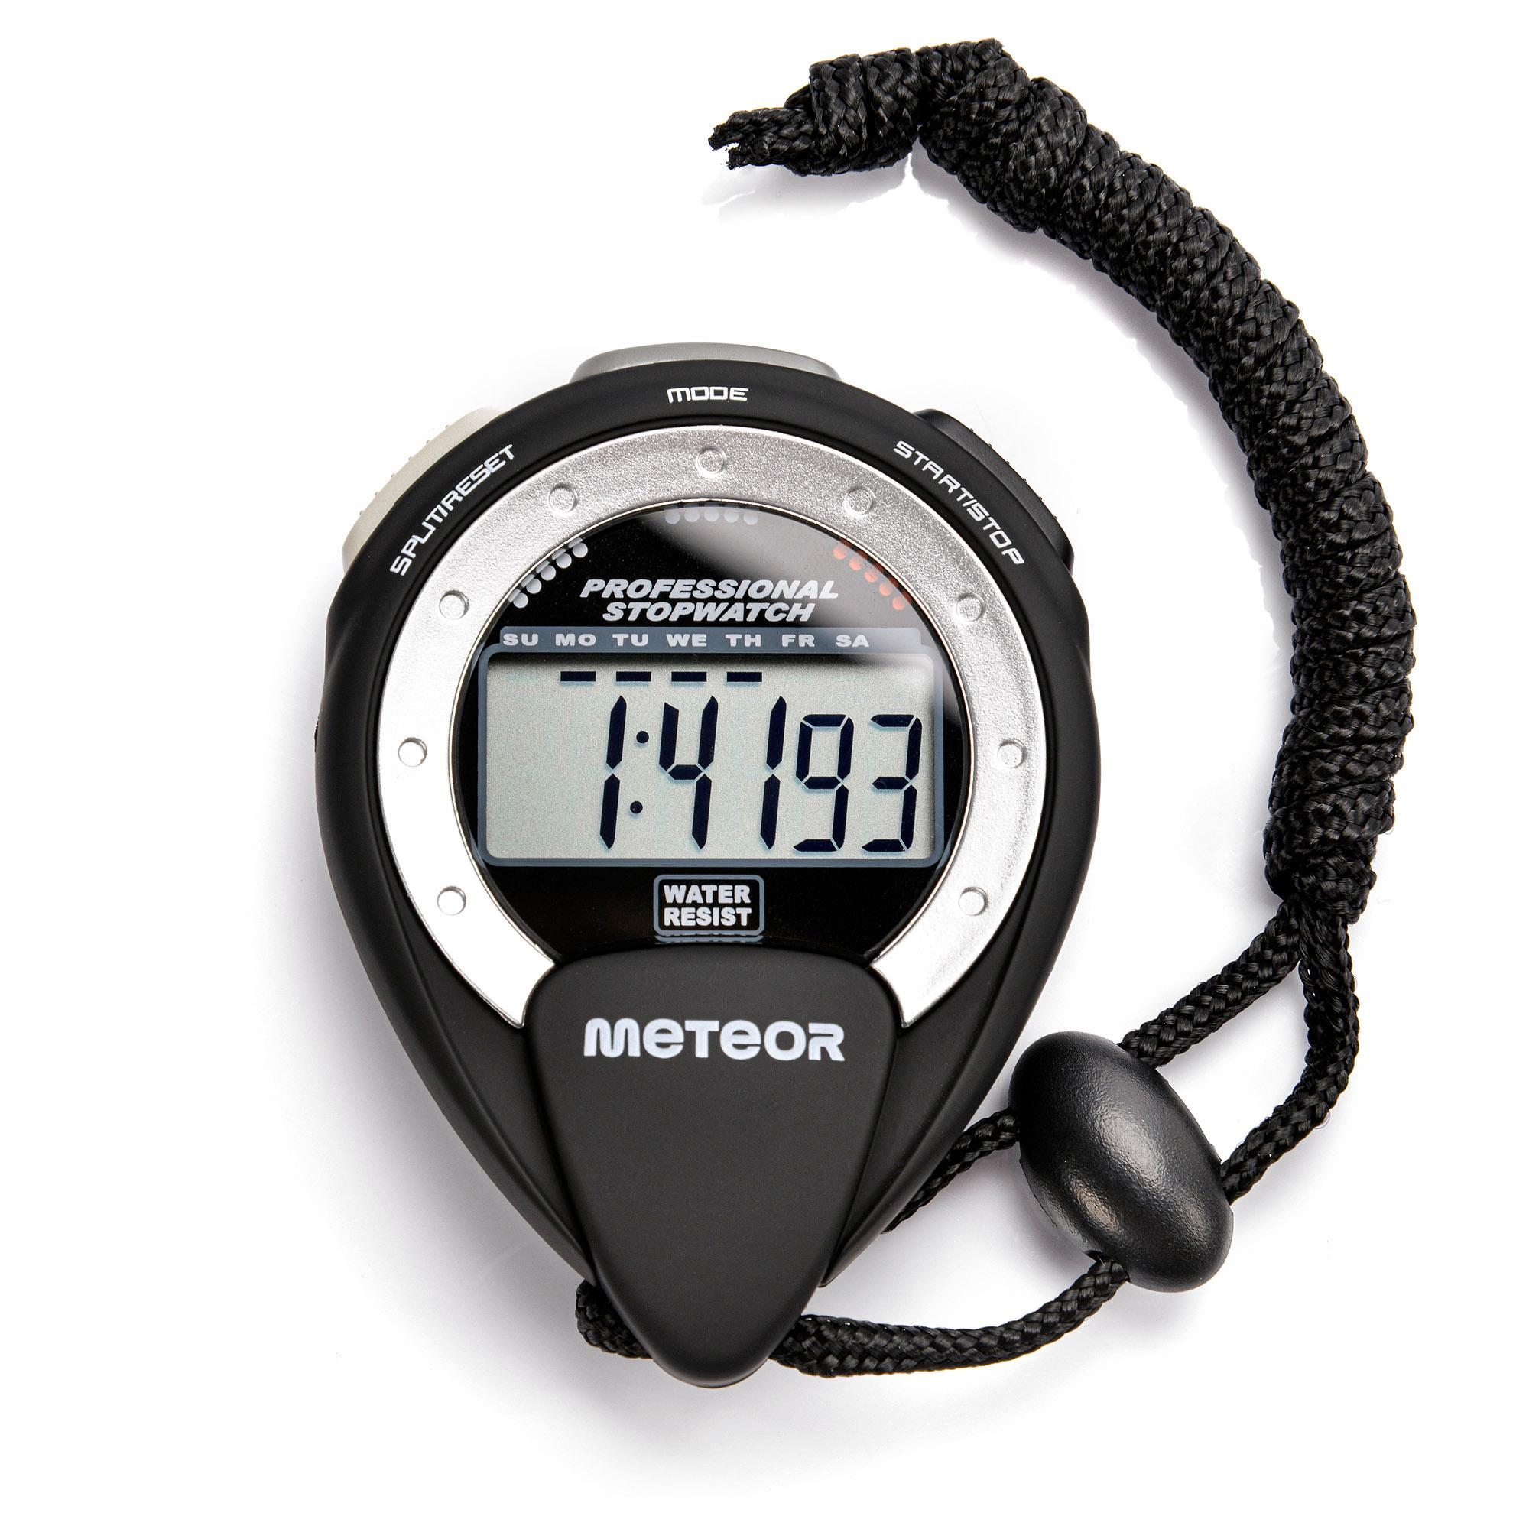
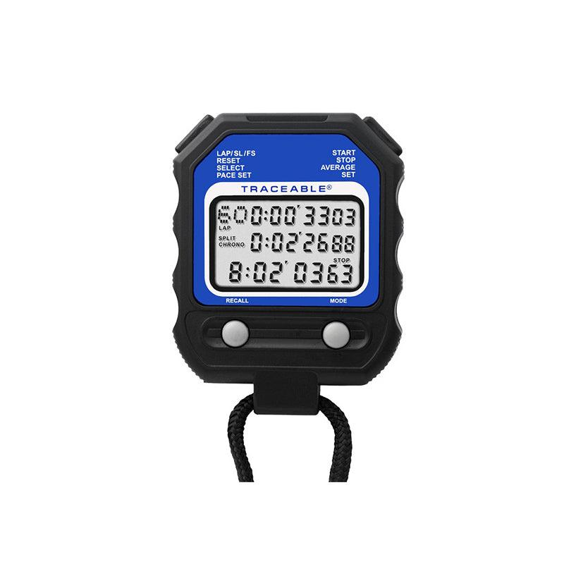
A Stopwatch is a time-measuring instrument used to accurately measure the elapsed time between the start and end of an event. Unlike a standard clock, which continuously displays the current time, a stopwatch begins timing only when activated by the user.
Stopwatches are widely used in sports, athletics, scientific laboratories, engineering experiments, education, manufacturing, medical procedures, and industrial testing.

Definition
# Source: AI Source: Provided by: [Data Path: Persons Table -> ID Column: 1, Name_En Column: Motasem Essam] -> From: [ChatGPT] on [7/17/2026]
A Stopwatch is a precision time-measuring instrument designed to measure the duration of an event by recording elapsed time from a user-controlled start to stop point.

Purpose
# Source: AI Source: Provided by: [Data Path: Persons Table -> ID Column: 1, Name_En Column: Motasem Essam] -> From: [ChatGPT] on [7/17/2026]
A Stopwatch is used to:
- Measure elapsed time.
- Time races and sporting events.
- Measure experiment duration.
- Record reaction times.
- Time manufacturing processes.
- Measure machine cycle times.
- Conduct laboratory experiments.

Principle of Operation
# Source: AI Source: Provided by: [Data Path: Persons Table -> ID Column: 1, Name_En Column: Motasem Essam] -> From: [ChatGPT] on [7/17/2026]
A stopwatch measures the time interval between:
- Start
- Stop
Modern digital stopwatches use a quartz crystal oscillator to generate highly accurate timing pulses. The internal electronics count these pulses and convert them into seconds, minutes, and hours.
Mechanical stopwatches use a spring-driven escapement mechanism to measure elapsed time.

Main Components
# Source: AI Source: Provided by: [Data Path: Persons Table -> ID Column: 1, Name_En Column: Motasem Essam] -> From: [ChatGPT] on [7/17/2026]
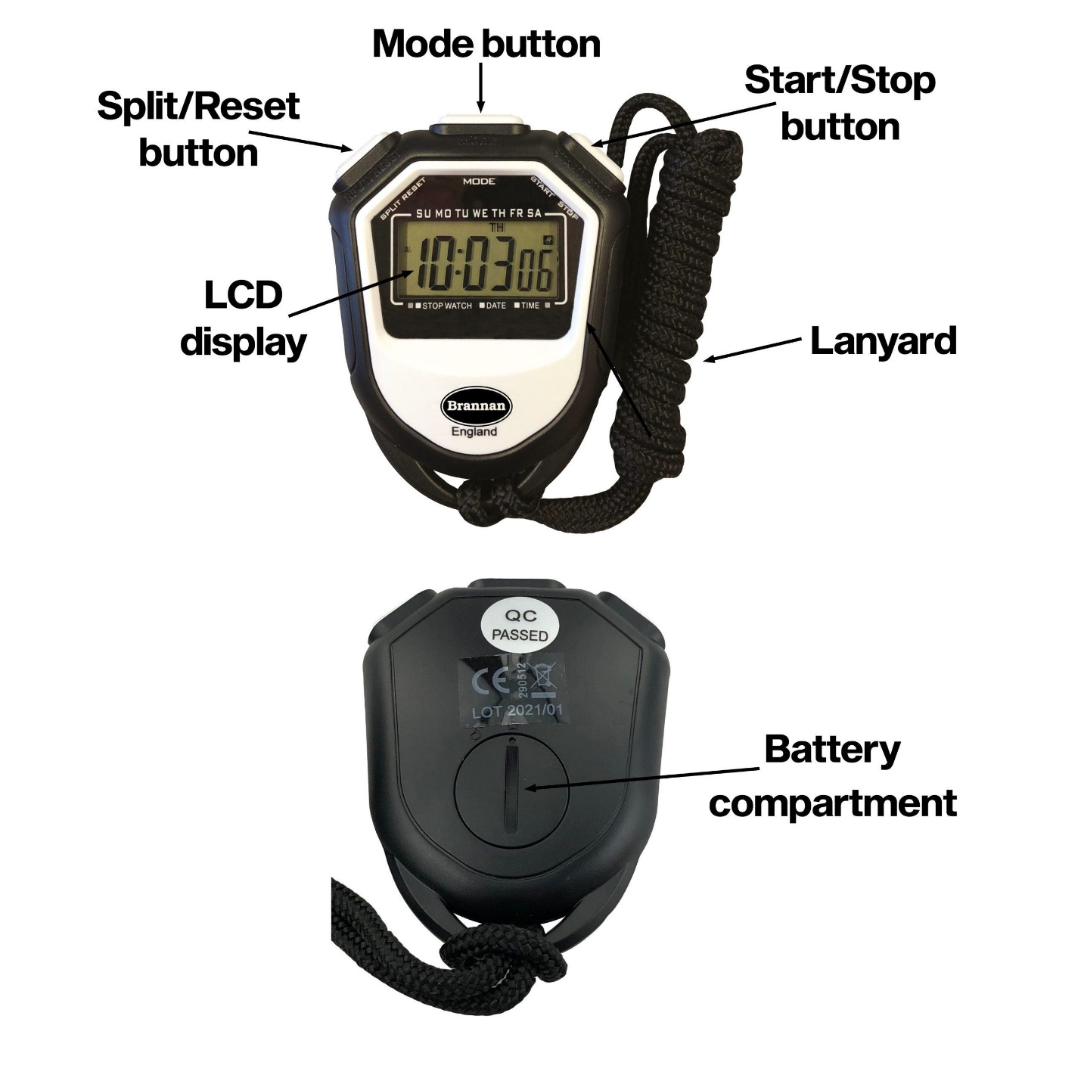
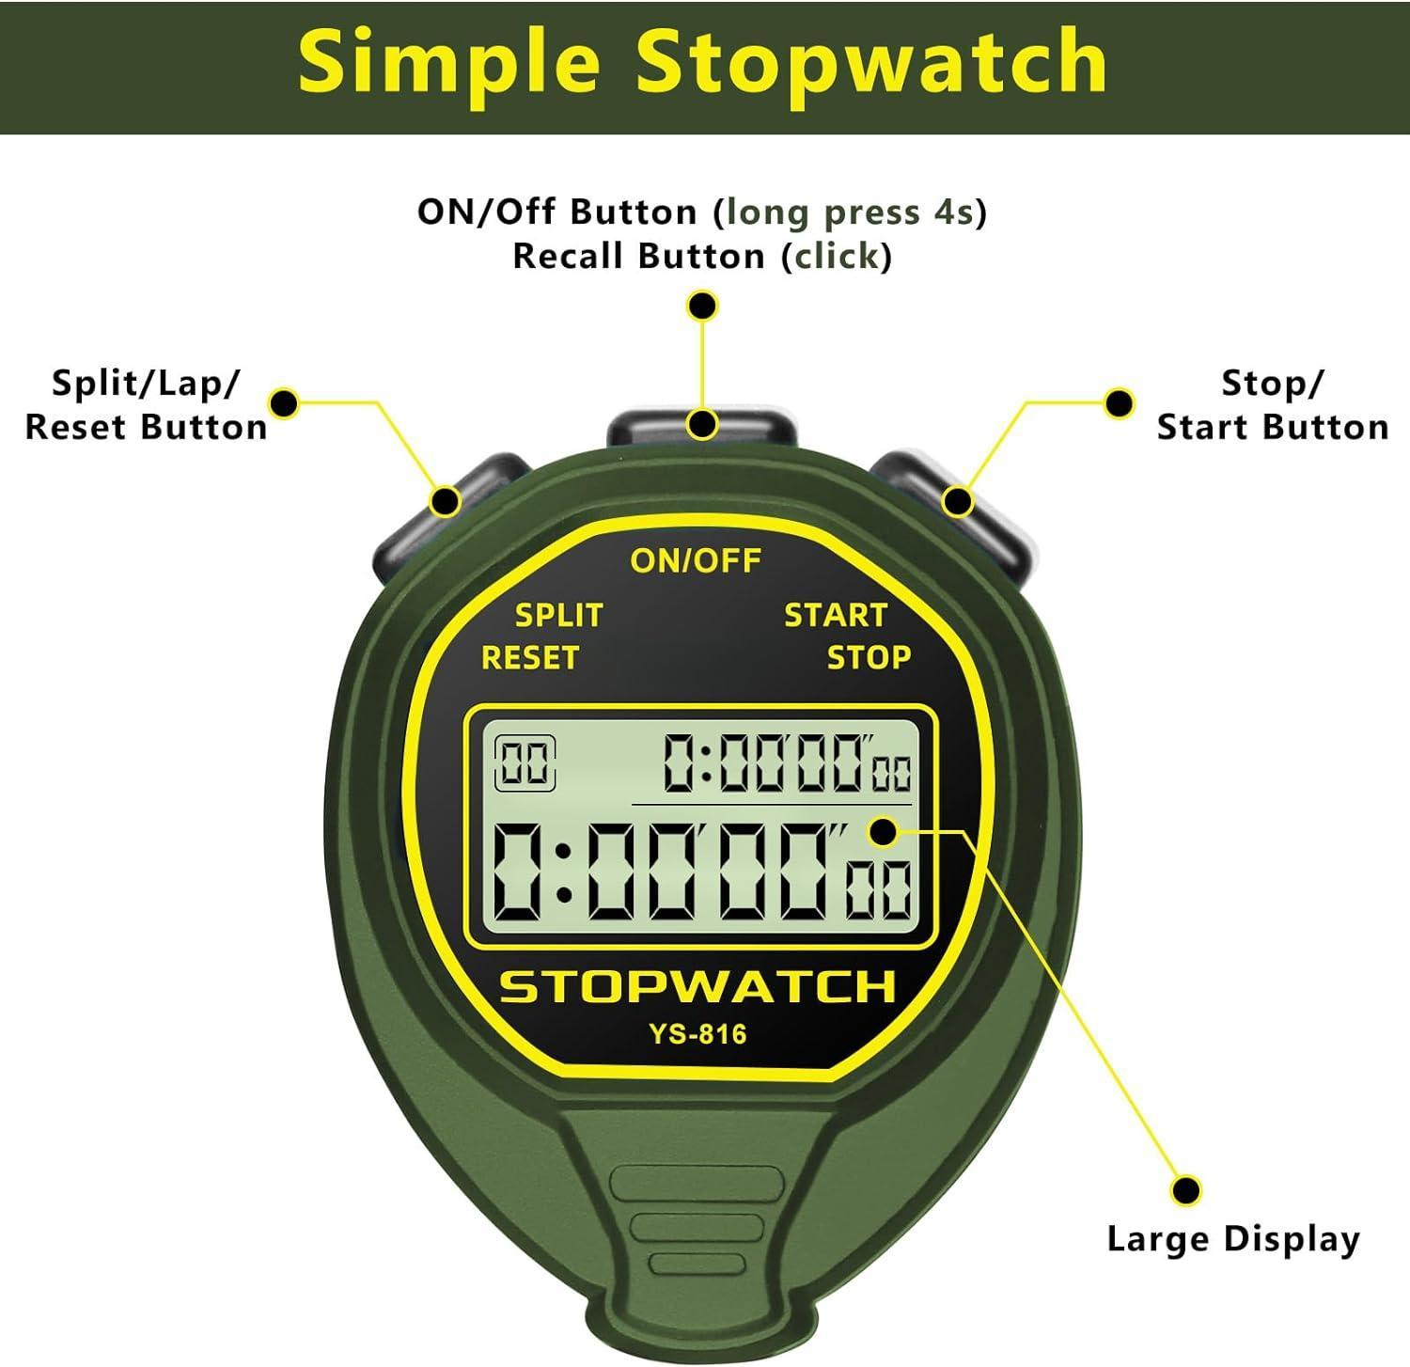
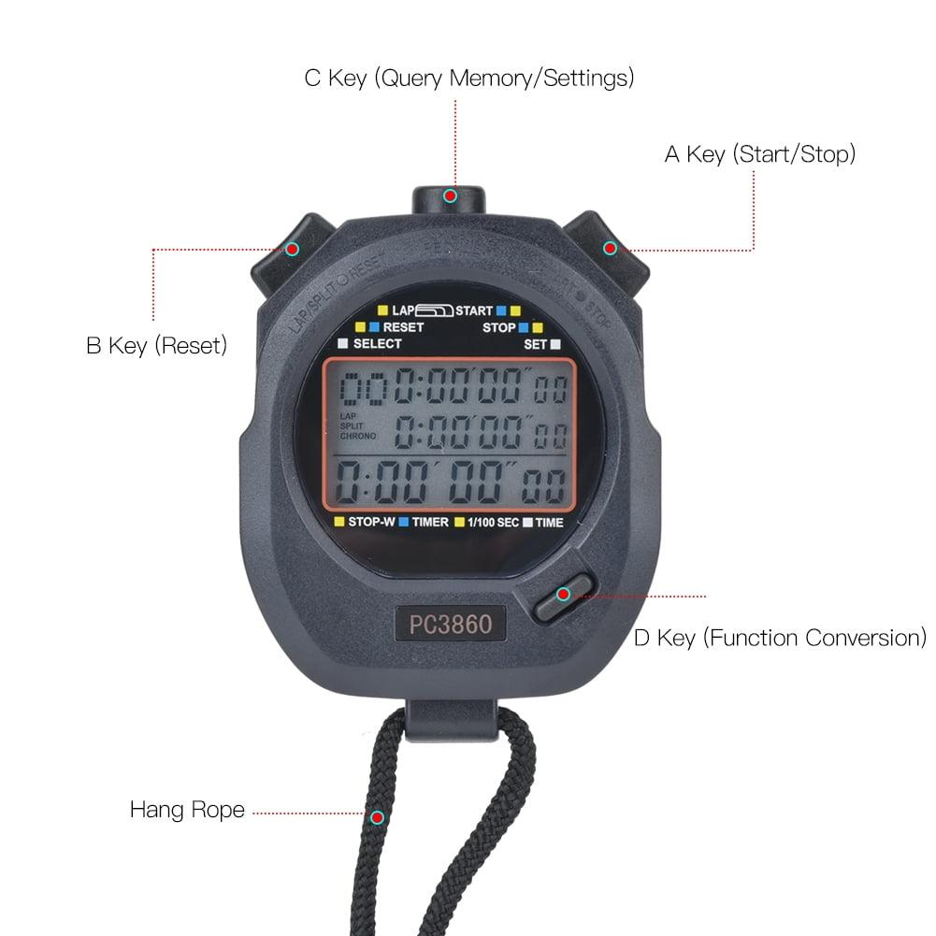
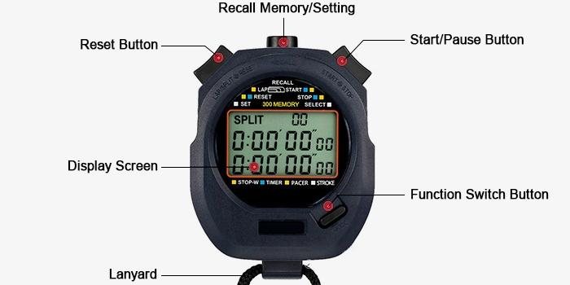
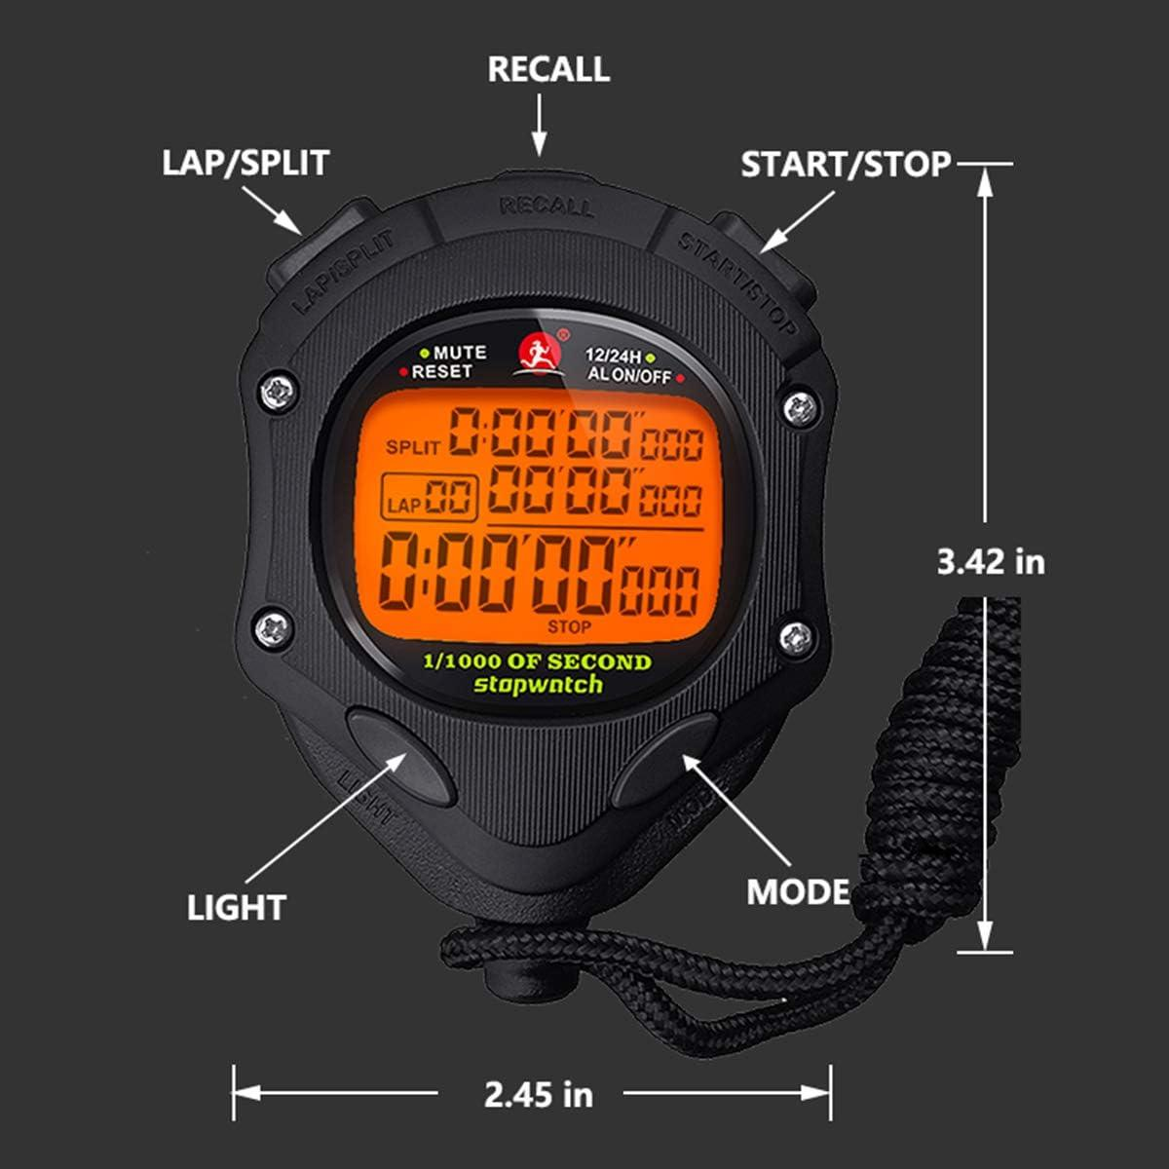
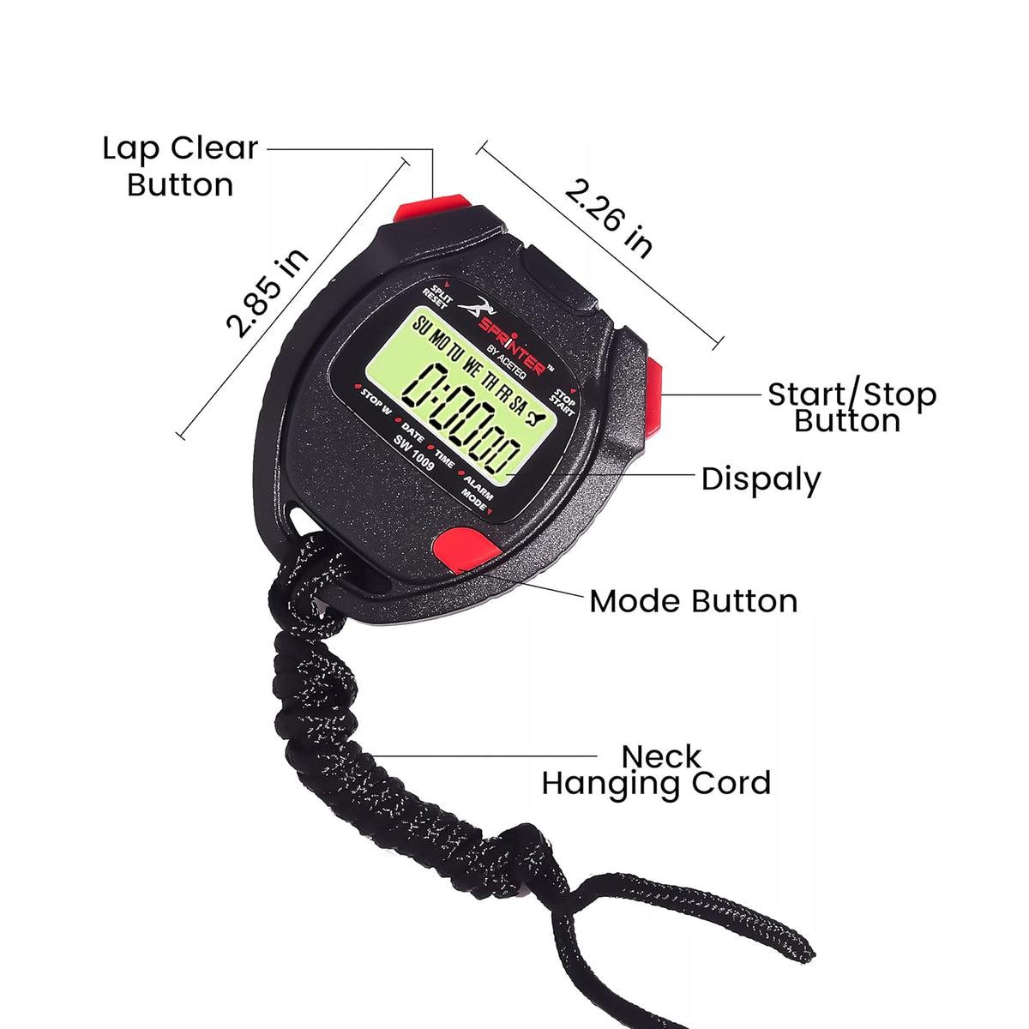
A typical stopwatch consists of:
- Display (analog dial or LCD)
- Start/Stop button
- Reset button
- Lap/Split button (many models)
- Internal timing mechanism
- Battery (digital models)
- Wrist strap or lanyard

Types of Stopwatches

1. Mechanical Stopwatch
# Source: AI Source: Provided by: [Data Path: Persons Table -> ID Column: 1, Name_En Column: Motasem Essam] -> From: [ChatGPT] on [7/17/2026]
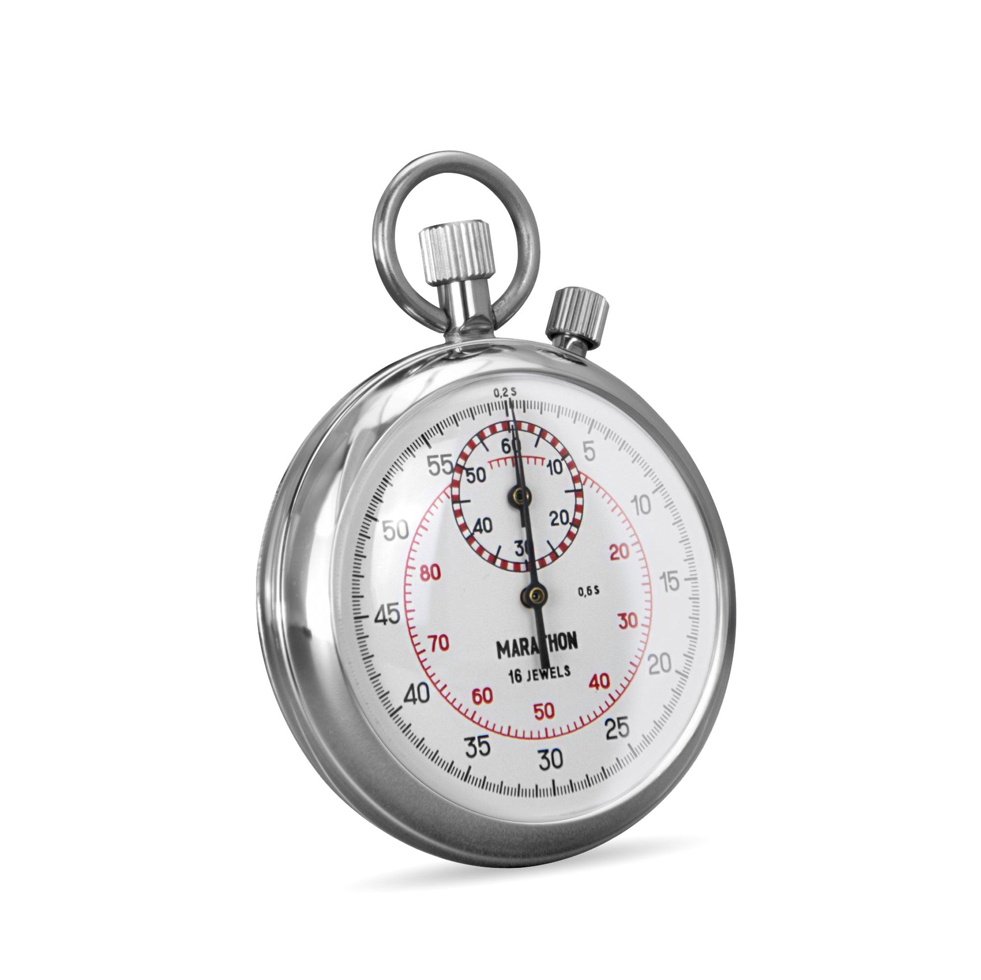
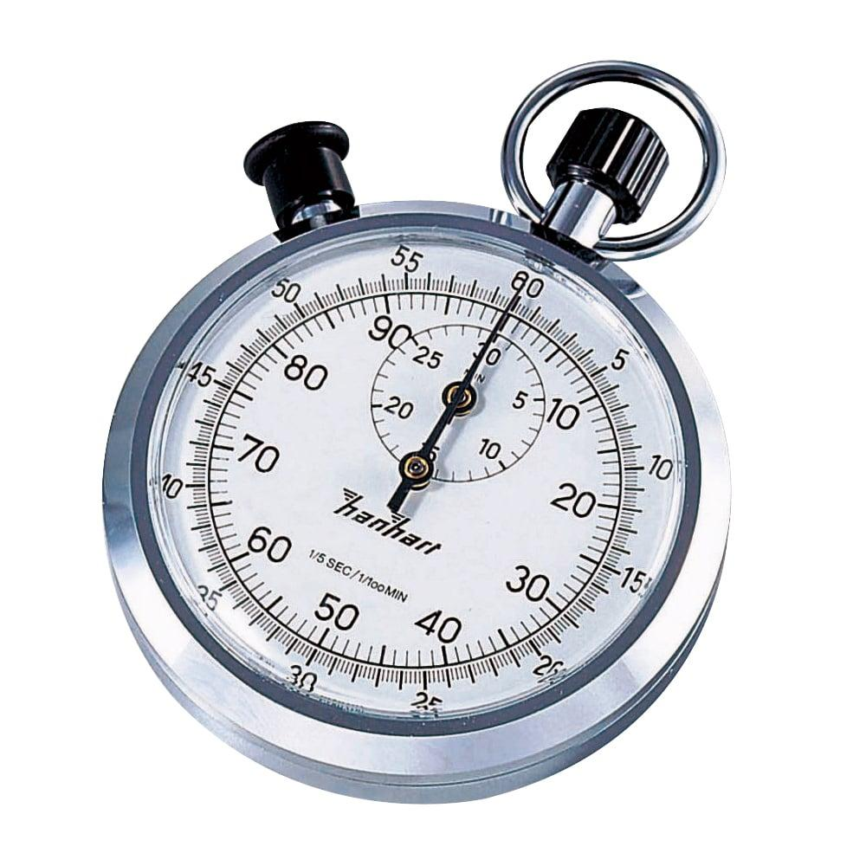
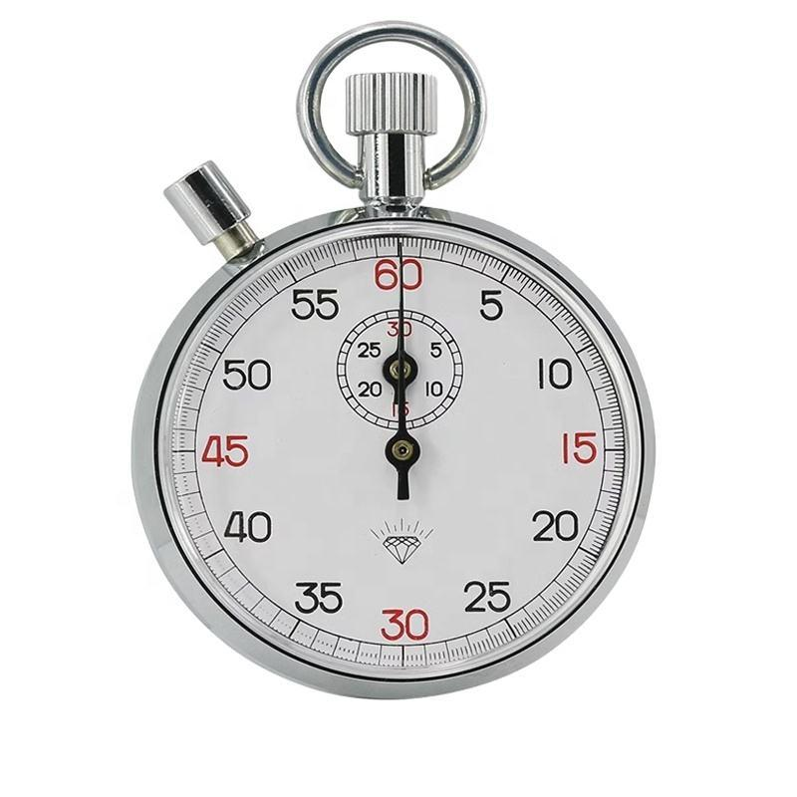
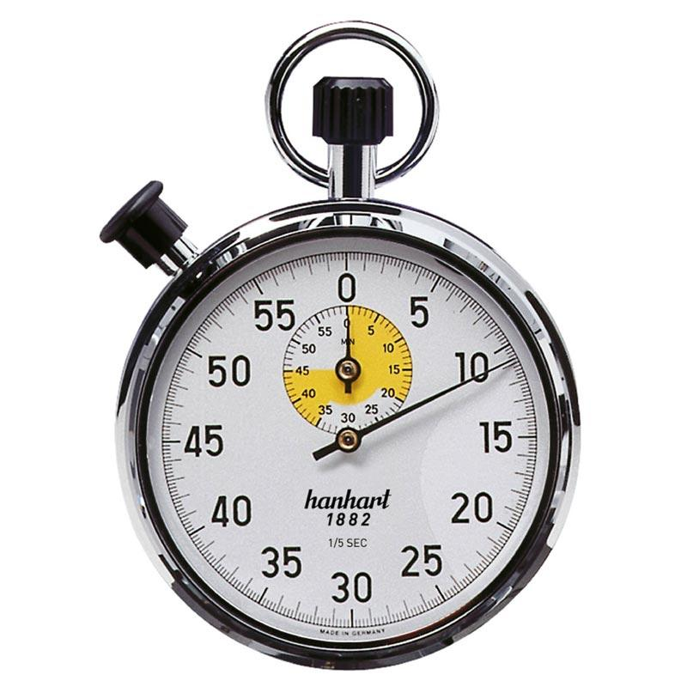
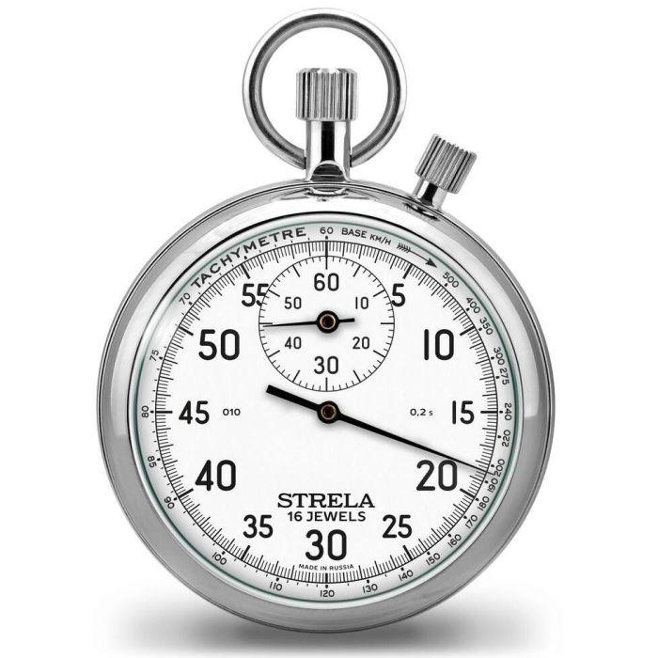
Description
Uses a spring-driven mechanical movement with rotating hands.
Features
- No batteries
- Analog dial
- Traditional design
Applications
- Historical timing
- Education
- Demonstrations

2. Digital Stopwatch
# Source: AI Source: Provided by: [Data Path: Persons Table -> ID Column: 1, Name_En Column: Motasem Essam] -> From: [ChatGPT] on [7/17/2026]
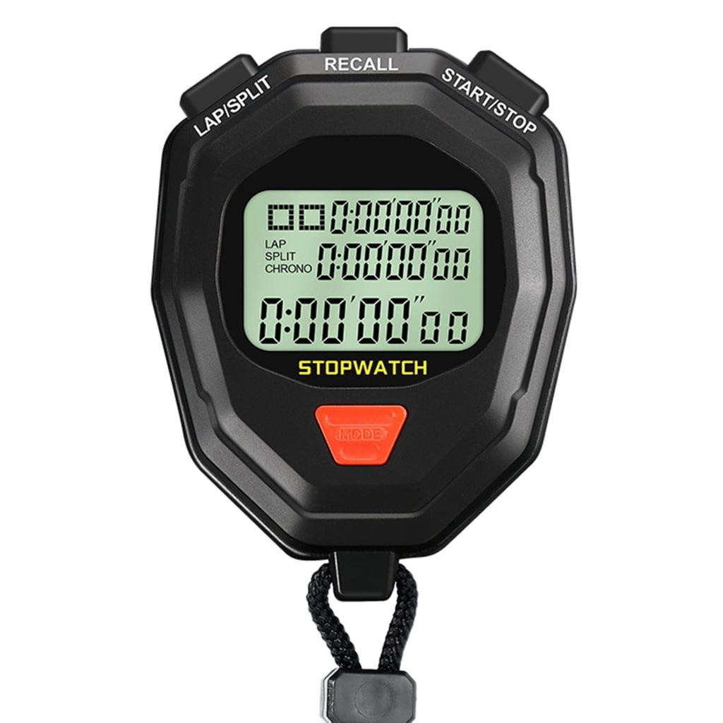
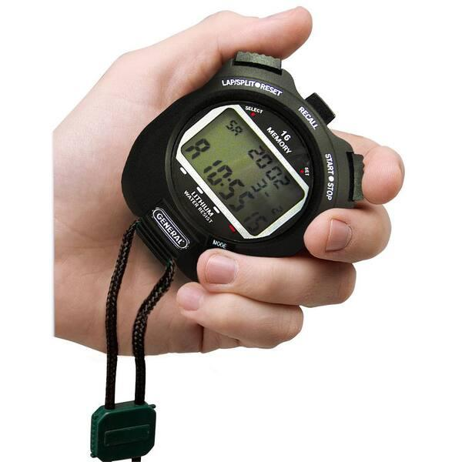
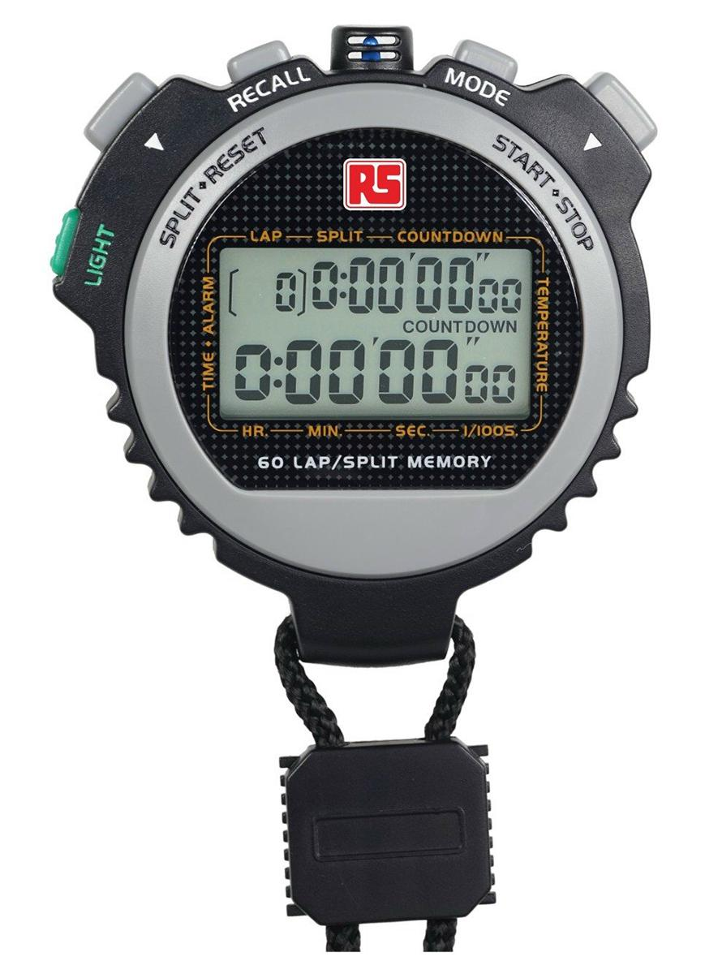
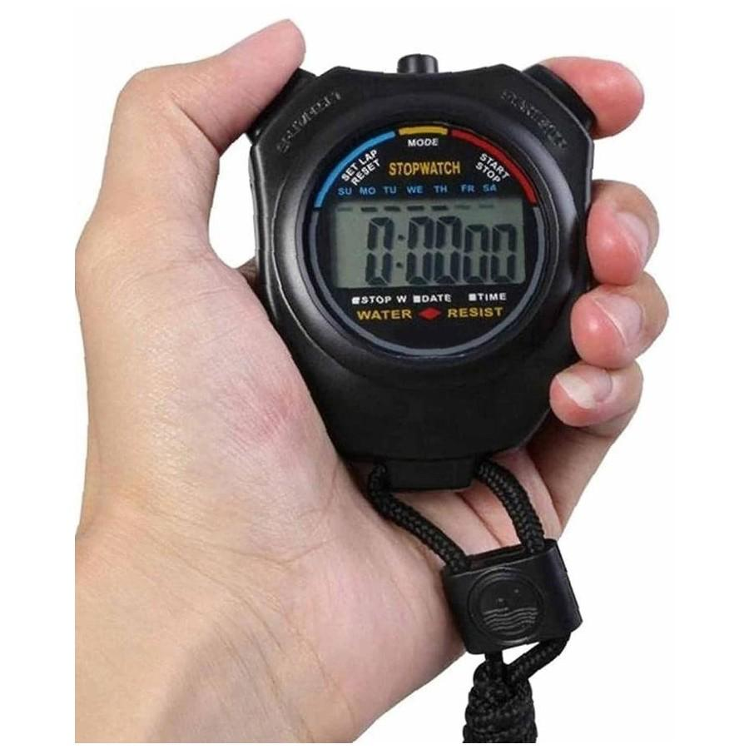
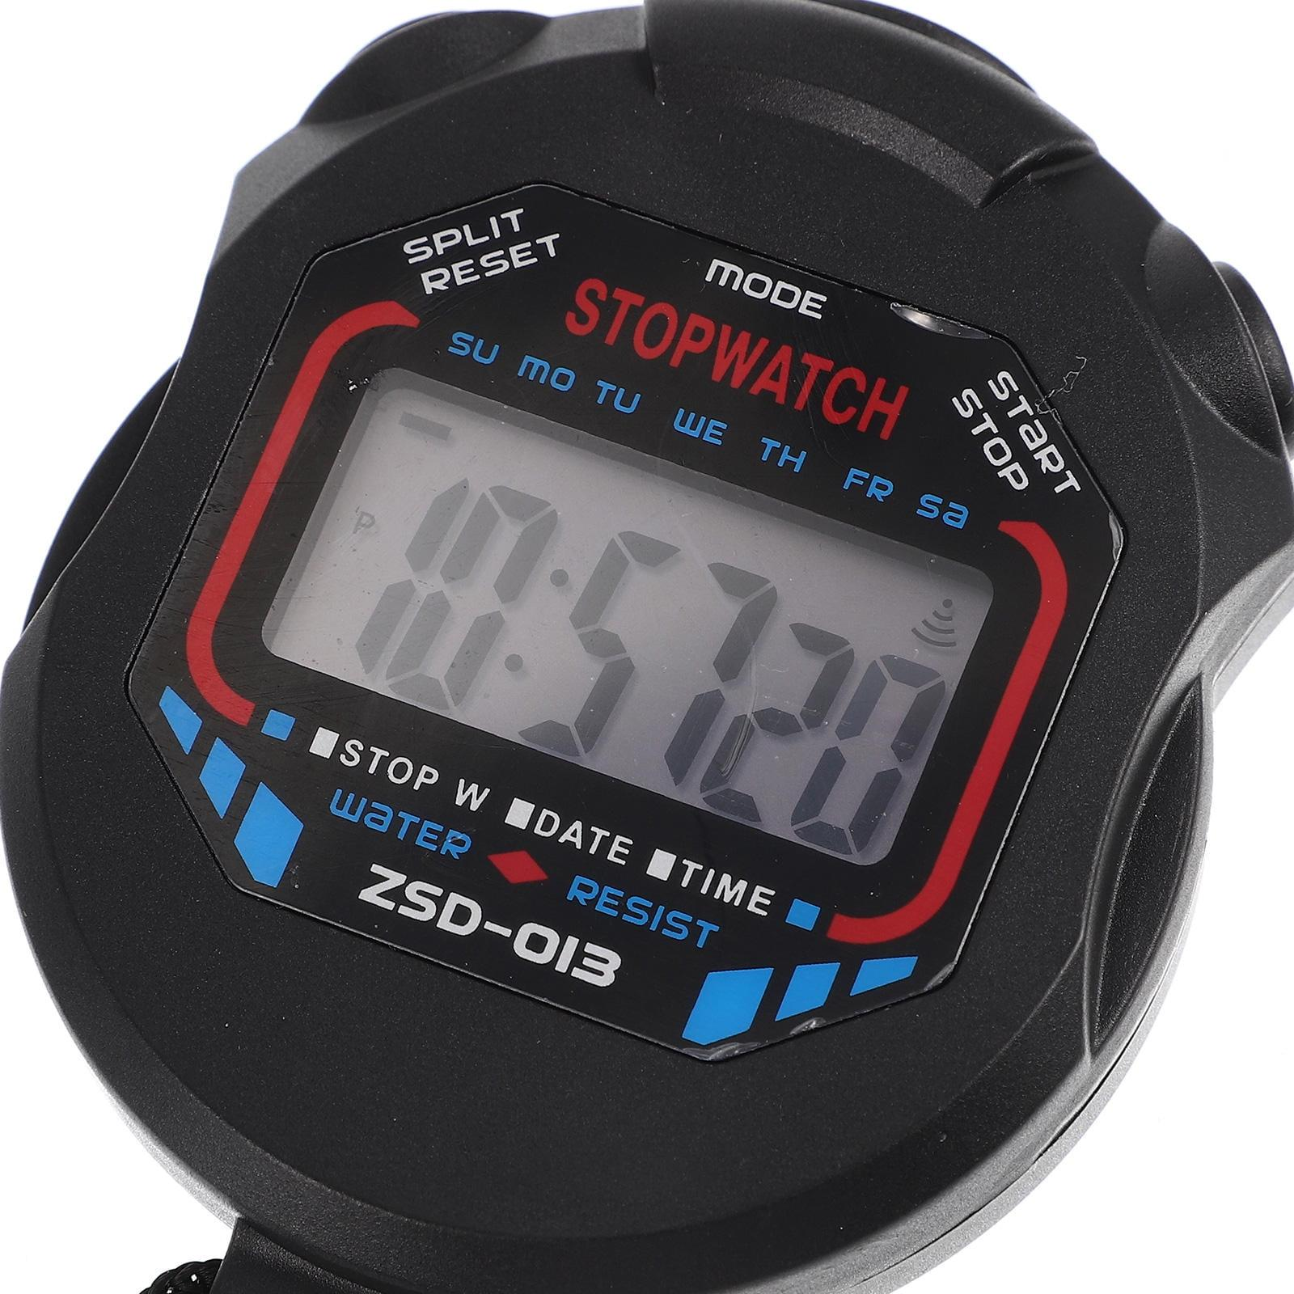
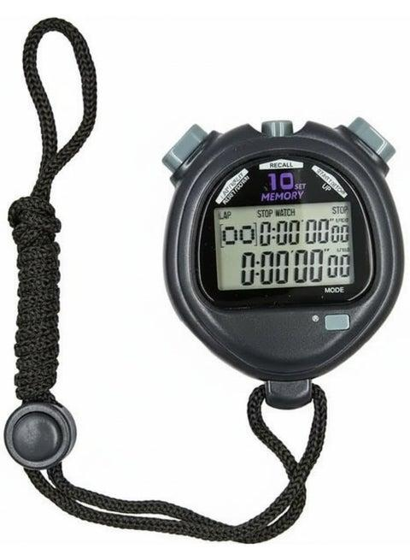
Description
Uses electronic circuitry and an LCD display to show elapsed time.
Features
- LCD display
- High precision
- Lap memory
- Split timing
- Alarm (some models)
Applications
- Sports
- Education
- Laboratories
- Industry

3. Sports Stopwatch
# Source: AI Source: Provided by: [Data Path: Persons Table -> ID Column: 1, Name_En Column: Motasem Essam] -> From: [ChatGPT] on [7/17/2026]


Description
Designed specifically for athletic events.
Features
- Lap timing
- Split timing
- Large display
- Water resistance
Applications
- Athletics
- Swimming
- Running
- Coaching

4. Laboratory Stopwatch
# Source: AI Source: Provided by: [Data Path: Persons Table -> ID Column: 1, Name_En Column: Motasem Essam] -> From: [ChatGPT] on [7/17/2026]
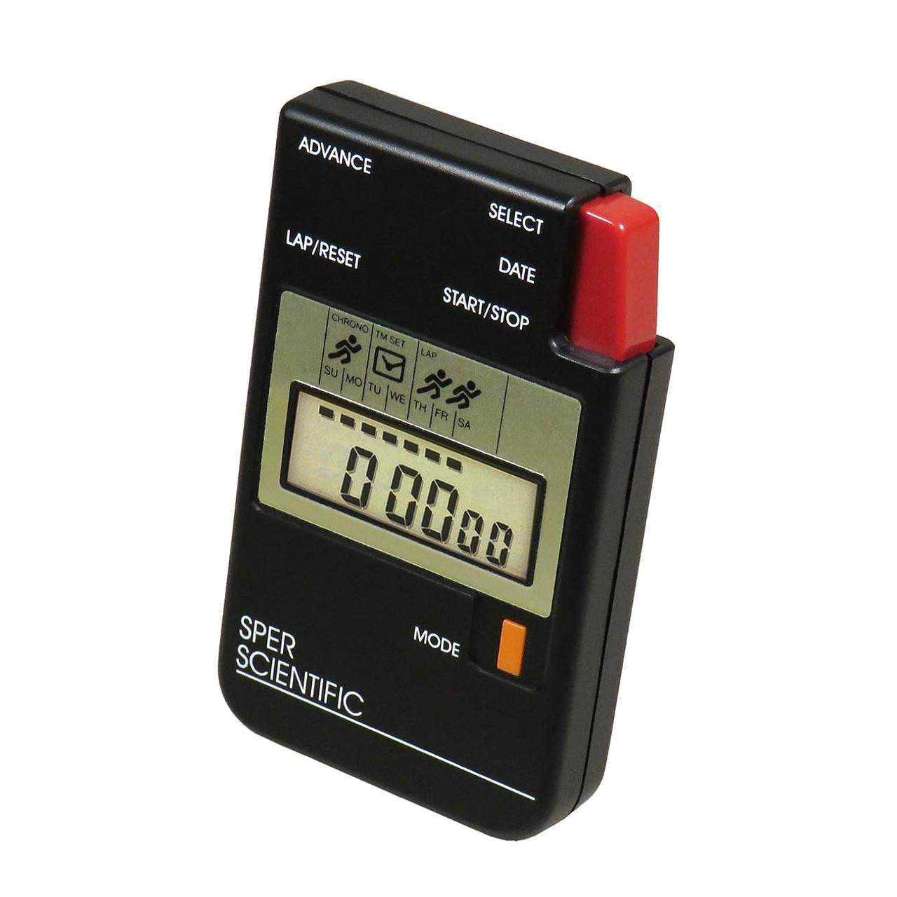
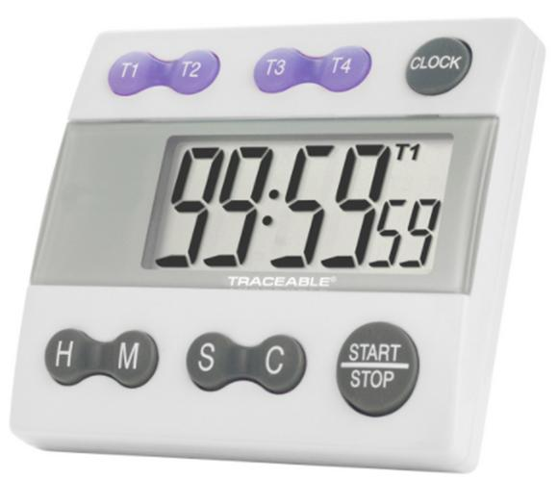
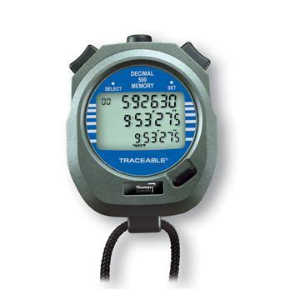
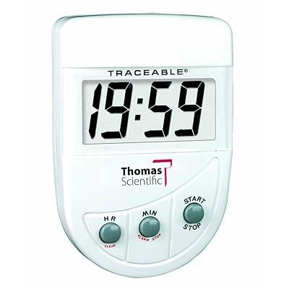
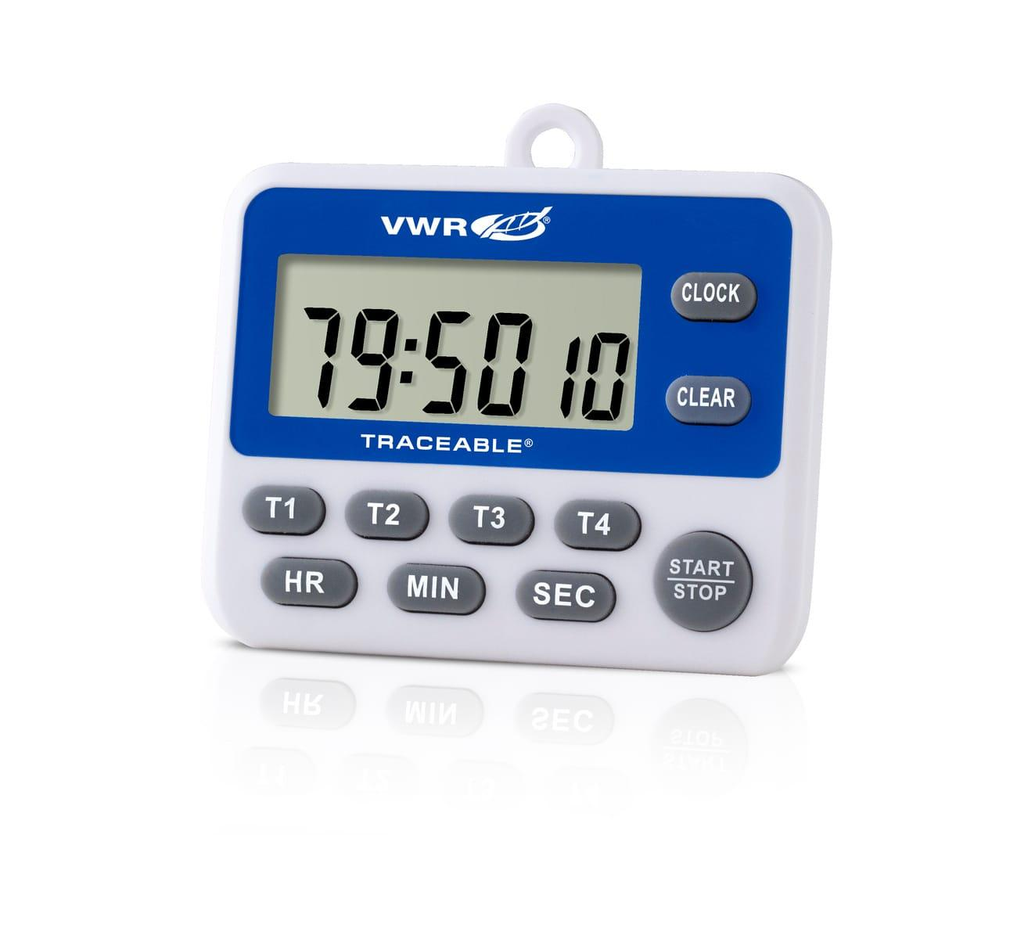
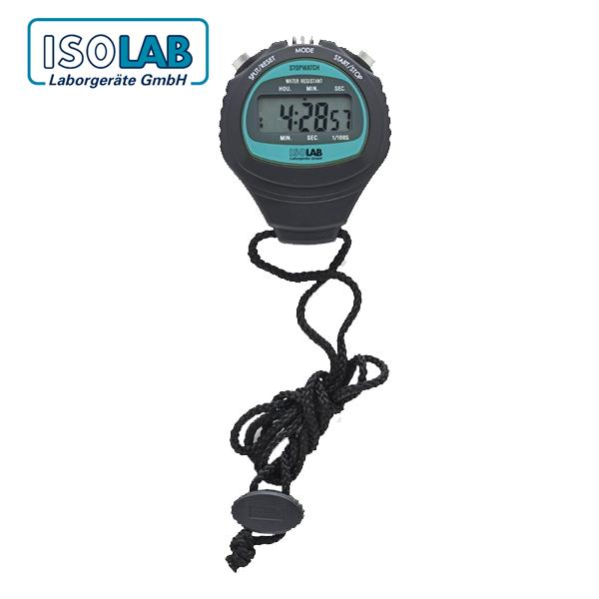
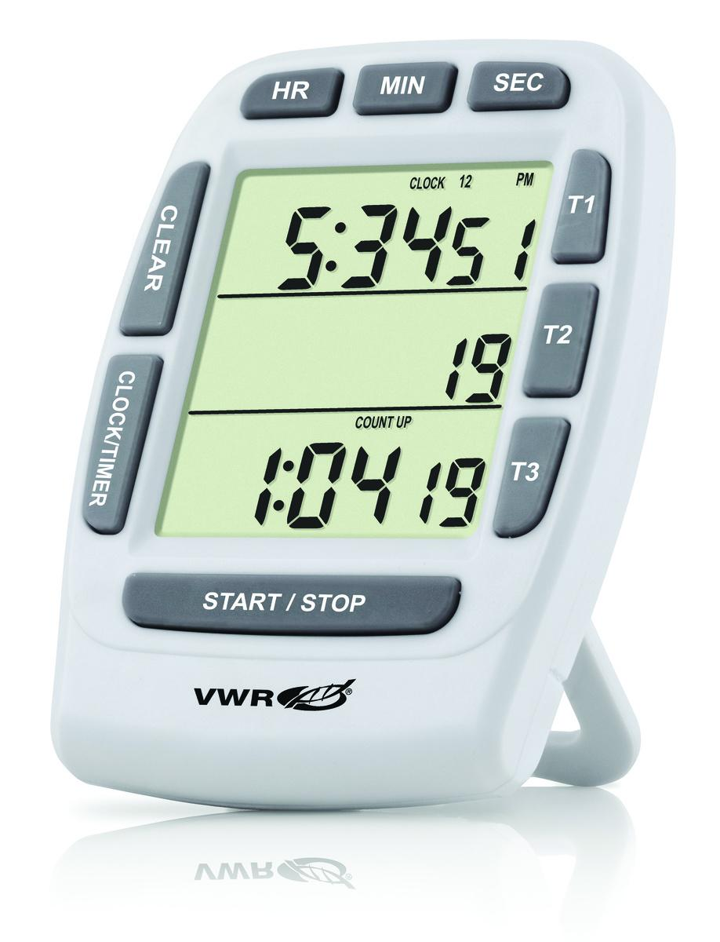
Description
Used in scientific experiments where accurate elapsed time is essential.
Applications
- Physics
- Chemistry
- Biology
- Engineering

Measuring Units
# Source: AI Source: Provided by: [Data Path: Persons Table -> ID Column: 1, Name_En Column: Motasem Essam] -> From: [ChatGPT] on [7/17/2026]
A stopwatch typically displays:
- Hours (h)
- Minutes (min)
- Seconds (s)
- Hundredths of a second (0.01 s)
- Thousandths of a second (0.001 s) on high-precision models

Measuring Range
# Source: AI Source: Provided by: [Data Path: Persons Table -> ID Column: 1, Name_En Column: Motasem Essam] -> From: [ChatGPT] on [7/17/2026]
Typical ranges:
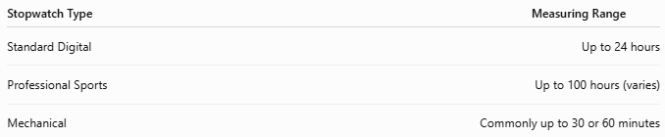
Stopwatch Type | Measuring Range
Standard Digital | Up to 24 hours
Professional Sports | Up to 100 hours (varies)
Mechanical | Commonly up to 30 or 60 minutes

Resolution
# Source: AI Source: Provided by: [Data Path: Persons Table -> ID Column: 1, Name_En Column: Motasem Essam] -> From: [ChatGPT] on [7/17/2026]
Typical resolutions:
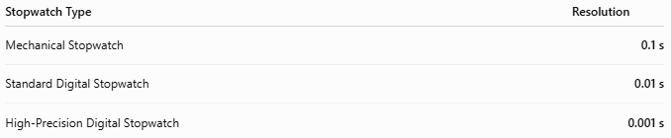
Stopwatch Type | Resolution
Mechanical Stopwatch | 0.1 s
Standard Digital Stopwatch | 0.01 s
High-Precision Digital Stopwatch | 0.001 s

Common Stopwatch Functions
# Source: AI Source: Provided by: [Data Path: Persons Table -> ID Column: 1, Name_En Column: Motasem Essam] -> From: [ChatGPT] on [7/17/2026]
- Start – Begins timing.
- Stop – Stops timing.
- Reset – Returns the display to zero.
- Lap Time – Records the time for one segment while timing continues.
- Split Time – Displays an intermediate time without stopping the timer.

How to Use a Stopwatch
# Source: AI Source: Provided by: [Data Path: Persons Table -> ID Column: 1, Name_En Column: Motasem Essam] -> From: [ChatGPT] on [7/17/2026]
- Reset the stopwatch to 00:00:00.
- Press Start when the event begins.
- Press Lap if intermediate times are needed.
- Press Stop when the event ends.
- Record the elapsed time.
- Press Reset to prepare for the next measurement.

Example
# Source: AI Source: Provided by: [Data Path: Persons Table -> ID Column: 1, Name_En Column: Motasem Essam] -> From: [ChatGPT] on [7/17/2026]
Suppose a runner completes a race in:
02:18.47
The elapsed time is:
- 2 minutes
- 18.47 seconds

Accuracy
# Source: AI Source: Provided by: [Data Path: Persons Table -> ID Column: 1, Name_En Column: Motasem Essam] -> From: [ChatGPT] on [7/17/2026]
Accuracy depends on:
- Timing mechanism
- Quartz oscillator quality (digital models)
- Calibration
- User reaction time when starting and stopping manually
Quartz digital stopwatches typically have excellent long-term accuracy.

Sources of Error
# Source: AI Source: Provided by: [Data Path: Persons Table -> ID Column: 1, Name_En Column: Motasem Essam] -> From: [ChatGPT] on [7/17/2026]
Instrument Errors
- Battery depletion
- Electronic malfunction
- Mechanical wear
- Calibration drift

Human Errors
- Delayed start
- Delayed stop
- Pressing the wrong button
- Recording mistakes

Environmental Errors
- Extreme temperatures
- Moisture
- Physical shock

Applications
# Source: AI Source: Provided by: [Data Path: Persons Table -> ID Column: 1, Name_En Column: Motasem Essam] -> From: [ChatGPT] on [7/17/2026]
Stopwatches are used in:
- Athletics
- Swimming
- Track and field
- Scientific laboratories
- Engineering experiments
- Manufacturing
- Medical testing
- Education
- Military training
- Fitness assessment

Advantages
# Source: AI Source: Provided by: [Data Path: Persons Table -> ID Column: 1, Name_En Column: Motasem Essam] -> From: [ChatGPT] on [7/17/2026]
A Stopwatch:
- Measures elapsed time accurately.
- Is simple to operate.
- Is portable.
- Supports lap and split timing.
- Provides high-resolution measurements.
- Is available in both analog and digital forms.

Limitations
# Source: AI Source: Provided by: [Data Path: Persons Table -> ID Column: 1, Name_En Column: Motasem Essam] -> From: [ChatGPT] on [7/17/2026]
A Stopwatch:
- Manual operation introduces human reaction-time error.
- Battery-powered models require periodic battery replacement.
- Mechanical models require maintenance.
- Standard handheld stopwatches are less precise than automated electronic timing systems.

Comparison with Other Time Measuring Instruments
# Source: AI Source: Provided by: [Data Path: Persons Table -> ID Column: 1, Name_En Column: Motasem Essam] -> From: [ChatGPT] on [7/17/2026]
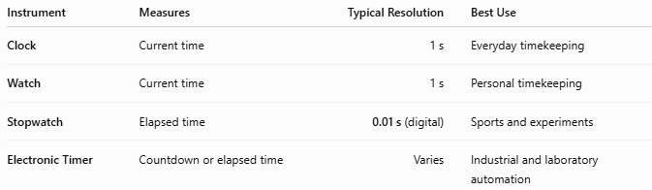
Instrument | Measures | Typical Resolution | Best Use
Clock | Current time | 1 s | Everyday timekeeping
Watch | Current time | 1 s | Personal timekeeping
Stopwatch | Elapsed time | 0.01 s (digital) | Sports and experiments
Electronic Timer | Countdown or elapsed time | Varies | Industrial and laboratory automation

Care and Maintenance
# Source: AI Source: Provided by: [Data Path: Persons Table -> ID Column: 1, Name_En Column: Motasem Essam] -> From: [ChatGPT] on [7/17/2026]
To maintain accuracy:
- Keep the buttons clean.
- Replace batteries when needed.
- Protect from moisture unless waterproof.
- Avoid dropping the instrument.
- Store in a protective case when not in use.
- Calibrate or verify periodically if required for critical measurements.

Common Mistakes
# Source: AI Source: Provided by: [Data Path: Persons Table -> ID Column: 1, Name_En Column: Motasem Essam] -> From: [ChatGPT] on [7/17/2026]
- Forgetting to reset before timing.
- Pressing Stop instead of Lap.
- Starting late due to slow reaction time.
- Reading the display incorrectly.
- Allowing the battery to become weak.

Key Points
# Source: AI Source: Provided by: [Data Path: Persons Table -> ID Column: 1, Name_En Column: Motasem Essam] -> From: [ChatGPT] on [7/17/2026]
- A Stopwatch measures elapsed time, not the current time.
- Common types:
  - Mechanical Stopwatch
  - Digital Stopwatch
  - Sports Stopwatch
  - Laboratory Stopwatch
- Typical digital resolution is 0.01 seconds.
- Common functions include Start, Stop, Reset, Lap, and Split.
- Widely used in sports, laboratories, engineering, manufacturing, medicine, and education.

Conclusion
# Source: AI Source: Provided by: [Data Path: Persons Table -> ID Column: 1, Name_En Column: Motasem Essam] -> From: [ChatGPT] on [7/17/2026]
A Stopwatch is a precision instrument designed to measure the duration of events with high accuracy. Whether used in athletic competitions, laboratory experiments, engineering tests, or industrial processes, it provides reliable elapsed-time measurements that are essential for performance evaluation and scientific analysis. Modern digital stopwatches, with resolutions as fine as 0.01 seconds or better, have largely replaced mechanical models due to their superior precision, ease of use, and additional timing functions such as lap and split timing.

